**U Plant E-Comm. Website**

A PROJECT REPORT

###### **Submitted by: -**

*SHARMILEE PATTNAIK 20BCE10405*

*SUMAN KUMAR BISOI 20BCE10418*

*VISHWAS KUMAR 20BCE10165*

*DHYEY CHIKANI 20BCE10912*

*BHANUPRATAP SINGH 20BCE10652*

##### ***in partial fulfilment for the award of the degree***

##### ***of***

**BACHEORS OF TECHNOLOGY**

in

COMPUTER SCIENCE AND ENGINEERING



**SCHOOL OF COMPUTER SCIENCE AND ENGINEERING**

**VIT BHOPAL UNIVERSITY**

**KOTHRIKALAN, SEHORE**

**MADHYA PRADESH - 466114**

##### April 2022

**VIT BHOPAL UNIVERSITY, KOTHRI KALAN, SEHORE**

**MADHYA PRADESH – 466114**

**BONAFIDE CERTIFICATE**

Certified that this project report titled **“U PLANT E-Comm. Website** is the bonafide work of **“, Sharmilee Pattnaik(20BCE10405),Suman Kumar Bisoi (20BCE10418),Vishwas Kumar (20BCE10165*) ,*DHYEY CHIKANI(20BCE10912), Bhanu Pratap Singh(20BCE10772*)*****”**

who carried out the project work under my supervision. Certified further that to the best of my knowledge the work reported here does not form part of any other project / research work on the basis of which a degree or award was conferred on an earlier occasion on this or any other candidate.

PROGRAM CHAIR PROJECT GUIDE

Dr.Shweta Saxena,

Assistant Professor Assistant Professor

School of CSE division VIT BHOPAL UNIVERSITY VIT BHOPAL UNIVERSITY

The Project Exhibition II Examination is held on 23rd April 2022

**ACKNOWLEDGEMENT**

First and foremost, I would like to thank the Lord Almighty for His presence and immense blessings throughout the project work.

I wish to express my heartfelt gratitude to Dr. Sandip Mal, Head of the Department, School of Computer Science for much of his valuable support and encouragement in carrying out this work.

I would like to thank my internal guide Dr. Shweta Saxena, for continually guiding and actively participating in my project, giving valuable suggestions to complete the project work.

I would like to thank all the technical and teaching staff of the School of Computer Science, who extended directly or indirectly all support.

Last, but not the least, I am deeply indebted to my parents who have been the greatest support while I worked day and night for the project to make it a success.

**Abstract**

UPlant is a simple and user-friendly website that serves as an online plant store. It will assist users in making their dream of a green office or house a reality! This platform intends to assist local gardeners in selling their plants online, as well as to provide a more easy and trustworthy way for users to search, browse, and buy the plants that best fit their wishes and requirements. Customers may also learn more about the plants by looking at the material on the website. This website assists local gardeners in reaching a broader audience with their products, which has been a difficulty for them due to the various rivals in the market. But, most importantly, we may be able to help to raising awareness about environmental protection and neighbourhood greening. Most gardeners have difficulty selling their plants and contacting their clients, and insufficient plant and tree specifications make it difficult for purchasers to make informed decisions. UPlant is a one-of-a-kind website where nature lovers may explore and purchase the highest-quality plants online and have them delivered.

**Tables of Content**

|  |  |  |
| --- | --- | --- |
| Chapter No. | Topic | Page No. |
| 1 | **Project description and outline** |  |
| 2 | **Related work investigation** |  |
| 3 | **Requirement Artifacts** |  |
| 4 | **Design methodology and its novelty** |  |
| 5 | **Technical Implementations and Analysis** |  |
| 6 | **Project Outcome and Applicability** |  |
| 7 | **Conclusions and Recommendation** |  |

**Chapter-1: Project description and outline**

**1.1 Introduction** Plants play an important role in the natural world and in people's lives. It is a critical resource for the globe and an important element of the world's biological diversity. People rely on plants to meet their most basic requirements. Because of the world's growing population, rising affluence, and urbanisation, these demands are fast increasing. Plants' capacity to meet these expanding demands is not a new problem. People's indifference toward environmental difficulties, according to the Reverend Thomas Malthus (1766-1834), will outstrip nature's ability to supply food.

"Gardeners can play a significant part in lowering global warming," according to the National Wildlife Federation. Taking care of plants and selling them will aid in the fight against this significant and potentially disastrous environmental problem caused by human carelessness. "As gardeners, we are both guardians and stewards of our environment," says Patty Glick, the report's author and the National Wildlife Federation's Global Warming Specialist. Despite the fact that gardeners can contribute to environmental conservation, there are important aspects that determine a gardener's business and profitability. These considerations would undoubtedly include the distance travelled to his or her consumers, the level of direct rivalry, and the site's lack of information.

**1.2Problem statement**

Even it provider of E-commerce goods and services rigorously follows these key factors to devise an exemplary e-commerce strategy, problems can still arise. Sources of such problems include:

1. Failure to understand customers, why they buy and how they buy. Even a product with a sound value proposition can fall if producers and retailers do not understand customer habits, expectations, and motivations. E commerce could potentially mitigate this potential problem with proactive and focused marketing research, just as traditional retailers may do.
2. Inability to predict environmental reaction. What will competitors do? Will they introduce competitive brands or competitive web sites? Will they supplement their service offerings? Will they try to sabotage a competitor's aite? Will price wars break out? What will the government do? Research into competitors, Industries and markets may mitigate some consequences here, just as in non-electronic commerce.
3. Over-estimation of resource competence. Can staff, hardware, software, and processes bandle the proposed strategy? Have estailers failed to develop employee and management skills? These issors may call for through resource planning and employee training.

## 4. Fallure to coordinate. If existing reporting and control relationships do not suffice, ne can move towards a flat, accountable, and flexible organizational structure, which may or may not aid coordination.

5. Failure to obtain senior management commitment. This often results in a failure to gain sufficient corporate resources to accomplish a task. It may help to get top management involved right from the start.

6. Failure to obtain employee commitment. If planners do not explain their strategy well to employees, or fail to give employees the whole picture, then training and setting up incentives for workers to embrace the strategy may assist.

## **1.3 Objectives**

Our mission is to create an online community of buyers and sellers of plants, trees, services, and knowledge, as well as to assist individuals in finding a way to disconnect from their hectic lives and reconnect with nature. This is a one-of-a-kind location where nature lovers may explore and purchase the highest-quality plants online and have them delivered. This would provide a customer with ease as well as quick gratification while purchasing a range of things. Information on how to cultivate the plants would also be provided in such a way that consumers would be educated and encouraged to raise them properly so that they could learn from a professional how to nurture and care for them. On the other side, we might assist our local gardeners in reaching a bigger audience with their products, which has been a difficulty for them due to the various rivals on the market. But, most all, we might be able to help to raising awareness about environmental conservation and community greening, which would be little steps toward rescuing our ecosystem from future damage.

## **1.4 Significance of Study**

This framework is relied upon to be easy to understand and will offer simple admittance to information just as administrations, for example, online leave the board, e-enlistment, and convenient report age, checking worker trainings, task the executives, project the executives and representative following. Without a representative administration framework, it is exceptionally monotonous for the human asset division to monitor every single worker and surprisingly harder for an undertaking chief to appoint assignments to the task group. The worker the executives framework will be created to give data of representatives and numerous different offices at the snap of a button.

Chapter 2: Related work investigation

2.1 Introduction

A validation study of e-commerce industry providers and items was conducted in order to determine the current composition of the e-commerce industry. Both e-commerce companies and users benefit from such a categorization. For the purposes of technological forecasting, trend analysis, planning, and strategizing, it allows managers to concentrate on smaller, more integral elements. Furthermore, it enables providers to have a deeper understanding of the competitive and cooperative dynamics in their business as well as the market. Furthermore, researchers may studyphenomena that are more comparable in strategy and consumer perception thanks to an experimentally determined classification of the sector. Organizations who have a substantial e-commerce initiative were chosen. Managers in charge of the project were sought from these major, medium, and small enterprises across the United States. Fifty-five strategists and technicians from various organisations took part in the event. Table 4 depicts the sample's vast range of variability. Almost a third of the participants worked for Fortune500 corporations with yearly revenues above $1 billion.

## **2.2 Review of literature on employee management**

### Organizations who have a substantial e-commerce initiative were chosen. Managers in charge of the project were sought from these major, medium, and small enterprises across the United States. Fifty-five strategists and technicians from various organisations took part in the event. Table 4 depicts the sample's vast range of variability. Almost a third of the participants worked for Fortune500 corporations with yearly revenues above $1 billion.

### **2.2.1 Review of related literature**

Empirical testing yielded industry sub-groupings known as e-commerce industry classes, which characterize the sector's functions and actors. The findings are summarised in Figure 1 by placing the classes within the framework of an industry value chain. Consumers are shown as "client-side" software and hardware users. Businesses

that provide their services. 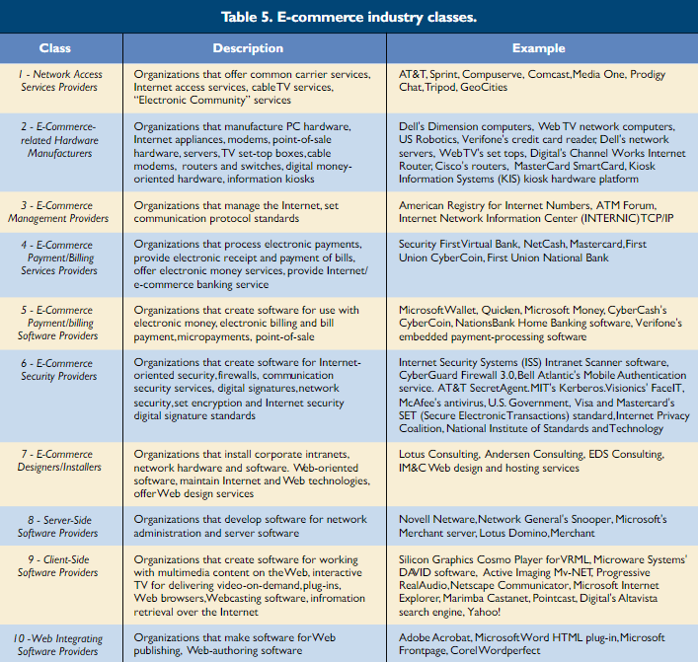

Users of e-commerce on the "server-side" are envisioned as users of e-commerce. Services for processing, validating, and managing invoicing and payments of e-commerce transactions are the most important middlemen in the process. Certain activities, such as e-commerce management, design/installation/maintenance services, and security, are represented in this way since they play a role across the value chain. E-commerce payment and billing software, as well as hardware, are required on both the server and client sides. The diagram's lines with arrows represent information flows, while lines without arrows represent applicability.

Participants agreed on 51 of the 61 e-commerce objects to be classified, therefore 10 were excluded. There were several huge shocks among the remaining classified objects, as well as some entirely predictable outcomes. Server hardware, for example, was expected to be classified by the majority of participants in the hardware manufacturing class—and it was—86 percent of the participants did so. Other items, on the other hand, were placed in classes that were not created during the experimental phase. The SET (Secure Electronic Transaction) standards item from Visa and MasterCard, for example, was projected to belong to the e-commerce management area. However, 68 percent of those who took part in the confirmatory phase assigned it to the e-commerce security category. Table  summarizes the findings.

### **2.2.3** Managerial Implications

There are a number of important implications for

both the supply and demand sides of e-commerce:

• Software for e-commerce billing and payment is

distinct from traditional software for invoicing

and payment.

• The e-commerce payment/billing class includes

both banks and other types of information

providers and will likely support major new inter-

mediaries.

• There is a large security class, which includes all

computer asset protection, privacy, and standards

issues.

• The Web-integrating software industry class is

restricted to software for converting documents,

images, or multimedia to Web pages.

• Browsers, information retrieval and search

engines are viewed as client-side applications.

• The server-side software class is very limited,

including only network operating systems,

administrative support software and software that

runs solely on the server.

• The designer and installer class includes organiza-

tions that install corporate intranets, network

hardware and software, maintain internet and

Web technologies, and so forth. This class is

likely to be a most competitive segment.

• E-commerce management is a class about which

there is little agreement; this may reflect the pre-

sent, generally chaotic state of the Internet.

• The e-commerce hardware class is the most

clearly delineated segment.

• The network access services class includes com

There are a number of important implications for both the supply and demand sides of e-commerce:

• Software for e-commerce billing and payment is distinct from traditional software for invoicing and payment.

• The e-commerce payment/billing class includes both banks and other types of information providers and will likely support major new intermediaries.

• There is a large security class, which includes all computer asset protection, privacy, and standards issues.

• The Web-integrating software industry class is restricted to software for converting documents, images, or multimedia to Web pages.

• Browsers, information retrieval and search engines are viewed as client-side applications.

• The server-side software class is very limited, including only network operating systems, administrative support software and software that runs solely on the server.

• The designer and installer class includes organizations that install corporate intranets, network hardware and software, maintain internet and Web technologies, and so forth. This class is likely to be a most competitive segment.

• E-commerce management is a class about which there is little agreement; this may reflect the pre-sent, generally chaotic state of the Internet.

• The e-commerce hardware class is the most clearly delineated segment.

• The network access services class includes common carriers as well as value-added services. Users see these services as competing for the same market.

2.3 Conclusion

E-commerce is a fast-paced, ever-changing phenomenon. Managers must immediately analyse where the market is heading, understand how to compete, build strategic partnerships, and construct and dissolve virtual organizations in such an environment. For producers of e-commerce products and services, information on how to segment this emerging business could serve as a useful categorization scheme.

**Chapter 3: Requirement Artifacts**

3.1

Requirements: Based on their functions, requirements can be classified into: (a) Functional

requirements, which describe system functionalities or services; (b) Non-functional requirements,

which define system properties and constraints (e.g. reliability, response time and storage

requirements). The functional and non-functional requirements can further be classified into few

types and have relationship as shown in Figure 1 [18]. As this research mainly concerns with

business requirements that will be used in designing user requirements and the business rules that

will be included in the use-case document, brief descriptions are provided for the three as follows:

(a) Business requirements: Represent high-level objectives of the organization or customer who

requests the system. They describe why the organization is implementing the system (the

objectives the organization hopes to achieve).

(b) User requirements: Describe user goals or tasks that the users must be able to perform with

the product.

(c) Business rules: The rules in the organization that affect the system, which include corporate

policies, government regulations, industry standards, accounting practices, and computational

algorithms.

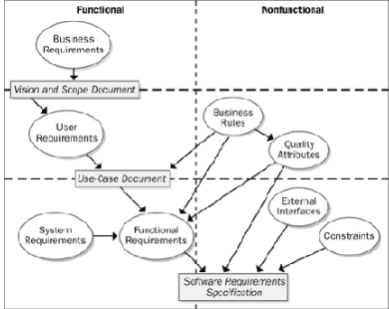

As depicted in Figure 1, the vision and scope document collects the business requirements into a

single document that sets the stage for the subsequent development work. It typically contains:

(a) Business requirements, which includes background, business opportunity, business objectives

and success criteria, customer or market needs and business risks;

(b) Vision of the solution, which includes vision statement, major features, assumptions and

dependencies;

(c) Scope and limitations, which includes scope of initial release, scope of subsequent releases,

limitations and exclusions;

(d) Business context, which includes stakeholder profiles, project priorities, operating environment.

**3.2**

2GB Hard Disk Space

○ 1 Gb RAM min.

● 20GB Hard Disk Space

○ 2 GB RAM or more

● 1024 x 768 Screen Resolution

● HTML

● CSS

● JAVA SCRIPT

● PHP

○ Android 4.4.2 +

○ iOS 6 +

SPECIFIC PROJECT REQUIREMENTS

● Visual Studio Code

● Android or iOS-based device

3.3 SUMMARY

System requirements are the most effective way of meeting the user needs and reducing the cost of implementation. They are the first and foremost important part of any project, because if the system requirements are not fulfilled, then the project is not

complete.

Chapter 4 : Design methodology and its novelty

**4.1 Introduction –** E-commerce needs special web-based software, which is usually known as e-commerce websiteoutlines major steps of Systems Development Life Cycle (SDLC) of e-commerce website, which are systems analysis/planning, design, building the system, testing and implementation. In the stage of system analysis/planning, the following are formulated: (a) Business objectives, which list the capabilities of the website;

(b) System functionalities, which list the information system capabilities needed to achieve the business objectives;

(c) Information requirements, which list the information elements that the system must produce in order to achieve business objectives. The emphasizes in the stage analysis/planning are defining business objectives then “formulating” system functionalities and information requirements based on those objectives. Unlike that defines the role of business rules in analyzing requirements, however, does not specifically discuss this role.

**4.2 Application methodology–**

1) **Browse and order the best quality of plants**

2) **Bridging the gap between sellers and buyers**

3) **Optimized user experience through numerous features**

4) **Aiding people for a greener and better future**

**4.3 real time usage**

We have incorporated this platform with an **idea to highlight plants**. Innovation have made possible for the operations of online platform easy enough to bring you the newest and best choice of plants, so we have moved the traditional operations from a shop-based operation to **primarily a platform-based one.**

But among all, **we could be able to contribute to raise awareness** regarding on the conservation of our environment and the greening of our community that would serve as small steps in **saving our environment from further destruction.**

**4.4 - Novelty -** Auto Suggest : This page enables the users to have recommendations on the best plant suitable for them based on the period of interest or the month they wanted to plant, the type of soil that their place have, the sun exposure, and their preferred growth rate of the plant. The Auto Suggest Page aims to give assistance to customers who doesn't have the exact choice of plant that they want to purchase because they are not sure if the plants would grow in their geographical area.

Chapter 5: **Technical implementation and analysis**

**OUTLINE**

Technical Implementation and Design can be defined in a variety of ways based on the context and field of expertise. For our app, we will define it as such: The design, layout, deployment, fabrication, and implementation of interactive technologies and immersive designs into both new and pre-existing spaces

**TECHNICAL CODE SNIPPETS**

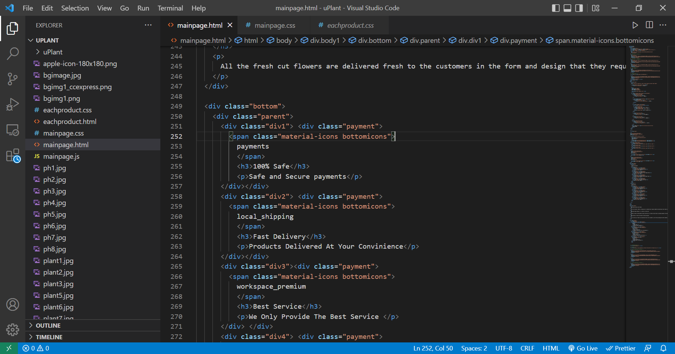

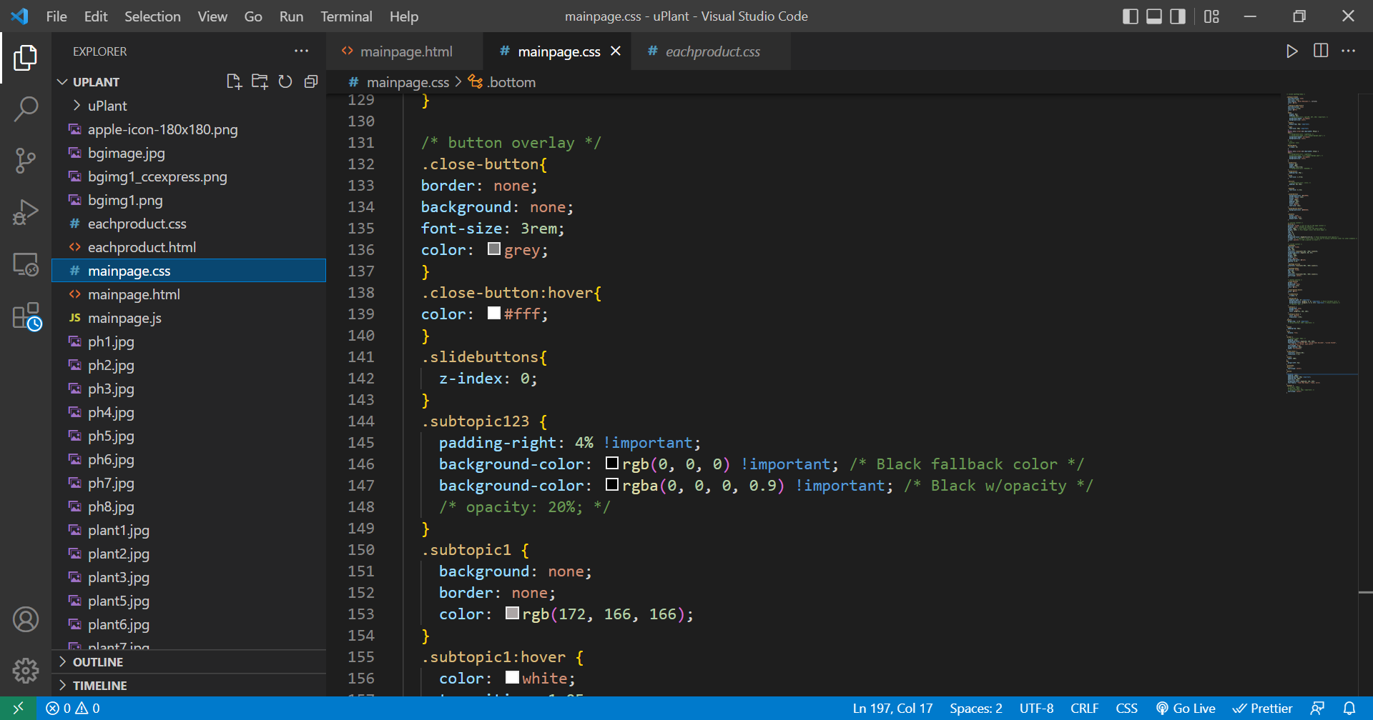

**PROTOTYPE SUBMISSION**

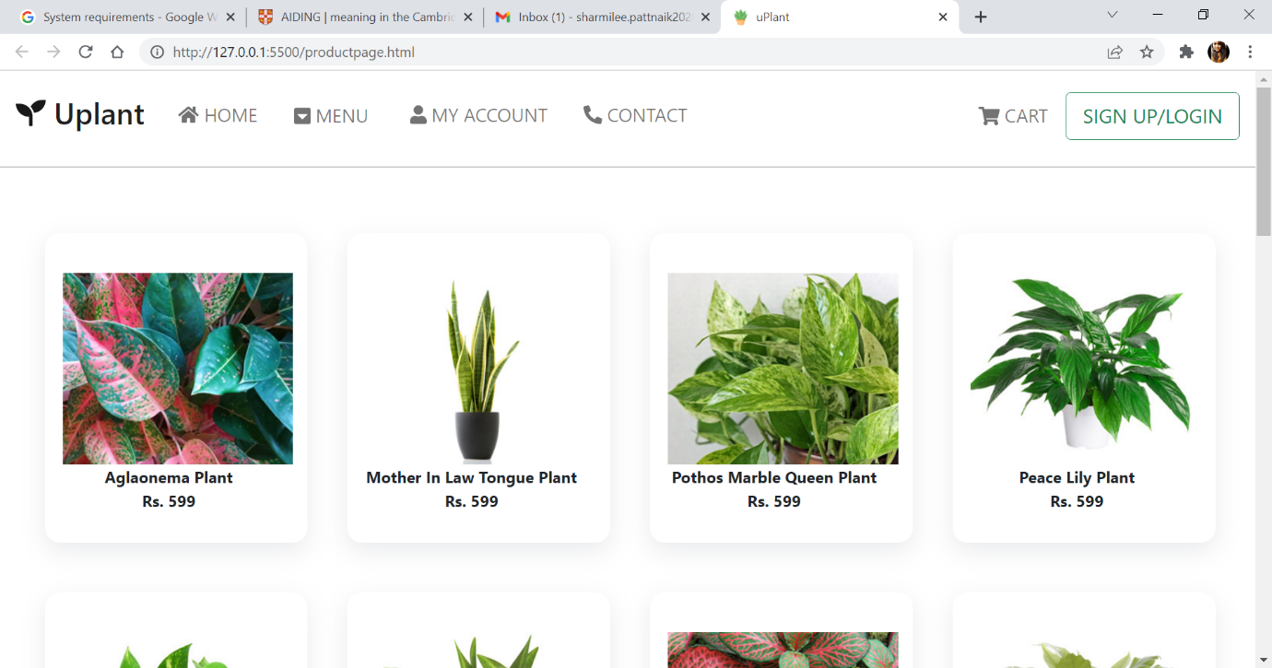

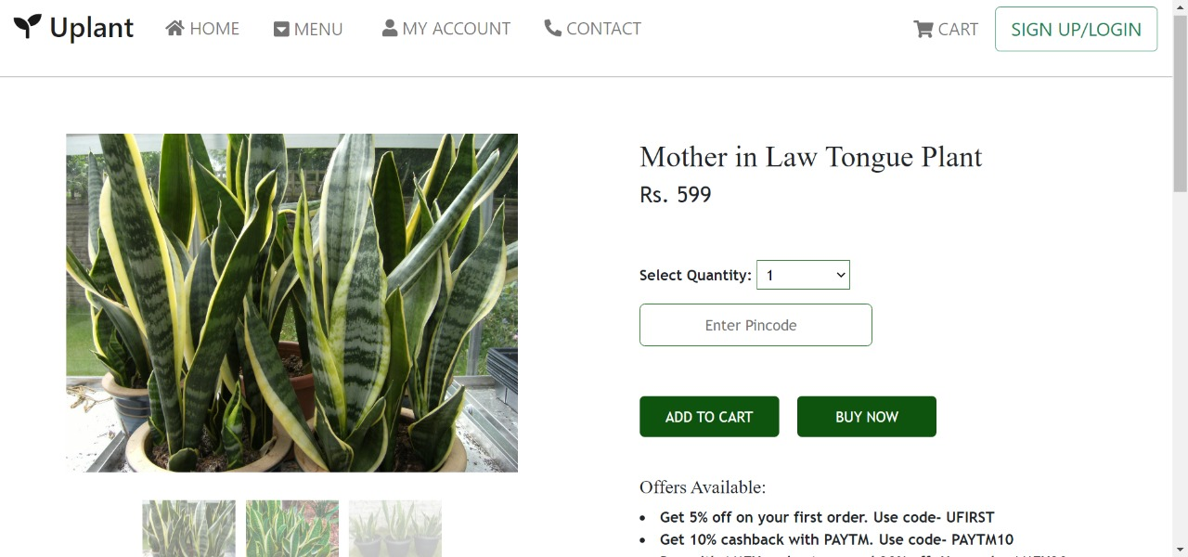

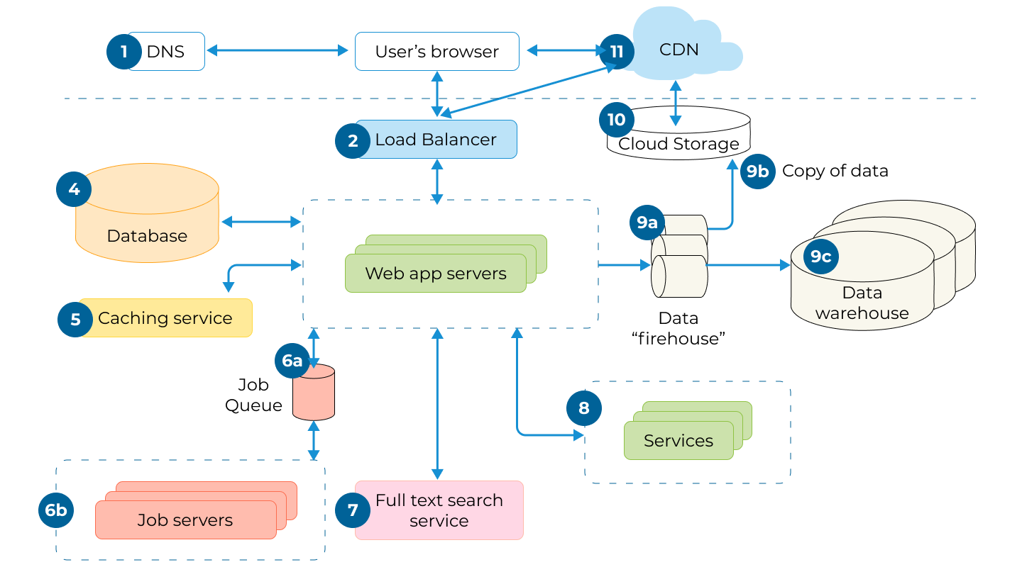

**Chapter-6: Project Outcome and Applicability**

**6.1 Learning experience**

This undertaking helped me to acquire a down to earth insight and apply the information absorbed from the past courses attempted. Putting the information acquired before and applying various methods from past courses was fascinating and certain ideas, apparatuses and strategies just checked out in the wake of seeing their application in a genuine situation. It was amazingly difficult now and again but it has been a great and advantageous learning experience.

There isn't by any stretch of the imagination any uncertainty that the representative administration framework would be a resource for any organization, little or huge.

**6.2 Project Applicability On Real-World Applications**

The goal of this website is to determine the efficacy of using e-commerce in the ornamental plant industry, as well as the benefits that may be gained by decorative plant farmers. This website employed a descriptive technique to provide a comprehensive overview of the scenario that existed at the time of the study, as well as the findings of the study to determine how much profit can be gained by using e-commerce in the ornamental plant industry, This website is conducted by discussing how orders, sales, and payments transactions are made using e-commerce. The results of this website show that e-commerce can improve sales efficiency for ornamental plant farmers, and of course, e-commerce technology can affect the level of ornamental plant sales.

.

**6.3 Inference**.

Plant e-comm website that can come handy for gardeners are the ones which lets you have knowledge about plants and plant shops near you. Through this website, users can easily show case their interest in planting and gardening.

With different types of features in our website, people can easily get to learn about different types of plants and also unique plants. UPlant also allows users to create their profile and have a tracks of their orders and search history etc.

**6.4 Applicability**

E-commerce applications is a bit of a misnomer since it may be interpreted in two ways: one, it refers to the use of e-commerce as a marketing medium; retail and wholesale; auctioning; e-banking; booking, and so on.

## **Most Common E-commerce Applications:**

### **1. Retail and Wholesale**

E-retailing or online retailing refers to the transaction of goods and services through online stores from businesses to consumers. It is achieved through means such as virtual shopping carts and e-catalogs. The applications of e-commerce in this sector is numerous.

### **2. Finance**

Finance and e-commerce is more connected today than ever. Banks and stock markets use e-commerce significantly in their operation. Online banking provides provisions such as balance check, bill payment, money transfer, etc. Online stock trading enables people to carry out trading electronically by giving information about stocks such as performance reports, analysis, charts, etc. through websites.

### **3. Manufacturing**

In manufacturing, e-commerce forms a medium for companies to execute the electronic exchange. Combined buying and selling, sharing market status, inventory check information, etc. enables groups of companies to fluidly carry out their operations.

### **4. Auctioning**

Applying e-commerce to auctions takes it to a more significant level where people can participate without any geographical boundaries. That leads to more participation, more negotiation, and helps to make auctions successful.

### **5. Marketing**

Marketing activities such as pricing, product features, and building customer relationships can be strengthened using e-commerce to provide users an enhanced and customized shopping experience. [Digital marketing strategies](https://mindster.com/top-6-digital-marketing-strategies-to-promote-your-mobile-app/) have become a significant way to promote businesses.

### **6. Online Shopping**

The shopping preferences of people have undergone a massive change in the last few years. “Go online” has become a mantra for all businesses to succeed. Online shopping is comfortable, convenient, and at most times, cost effective. The prosperity of [online shopping apps](https://mindster.com/best-online-shopping-apps-india/) such as Flipkart, Amazon are proof of this.

### **7. Mobile and Web Applications**

Popularly called mobile commerce or m-commerce applications, this is a subset of retail e-commerce. Mobile or [web application development](https://mindster.com/web-application-development/) has become a staple for brands to showcase their business capabilities. The consumer carries out purchases through mobile or web applications that are optimized for the retailer. These applications also ensure payment security through safe e-payment methods.

### **8. Online Booking**

Travel and tourism is a thriving industry today, and online booking is an ecommerce application that is growing as a result of it. Online booking helps people book travel essential services like train/flight tickets, hotel rooms, tourism packages, transportation services, etc. It makes travel very convenient and easy for people as everything can be set from the tip of the fingers.

### **9. Online Publishing**

Digital magazines and e-books are slowly replacing traditional printed books. It has several advantages such as portability, lightweight, accessible from everywhere, etc. They are also environment friendly as they help in reducing paper and saving trees. Due to these reasons, online publishing or e-publishing has been seeing a rise in popularity.

### **10. E-banking**

E-banking or internet banking is an e-commerce application that has simplified time-consuming and complex banking processes for people. It enables bank users to perform transactions easily online without having to wait in long queues in banks. Every major bank has its own online application today to provide virtual banking services to its customers.

**Chapter-7: Conclusions and Recommendation**

**7.1Conclusion**

This plant-related e-commerce platform is completely functional and has proven itself in the hands of testers and assessors. According to the conclusions of this study, the platform received favourable comments from all participants during the testing since it is a time-saving, accessible, up-to-date, and simple to use website. The results show that the platform is a trustworthy website for gardeners who want to sell their products online and for individuals who want to acquire plants. The essential parts of the e-commerce business model must be resolved when examining the requirements of e-commerce websites for SMEs in order to greatly help the company success. This can be realised at the outset of the requirement analysis process by creating a logical sequence of activities. Following the identification of business opportunities that SMEs can exploit, the following activities are carried out: resolving market opportunities, competitive environment, and advantage, formulating business objectives, resolving value proposition, revenue model, and marketing strategy, as well as designing organisations and business rules. Following the formulation of these, significant components of the website may be built in accordance with them, which can then be referenced in subsequent development activities. Options for SMEs to create e-commerce businesses include opportunities that lead to pure online businesses as well as opportunities to enhance existing off-line (conventional) businesses. The suggested technique may be used to analyse e-commerce website needs in order to resolve both sorts of opportunities stated in the case studies.

**7.2Recommendation**

This research has a lot of room for improvement. The proponents acknowledge the following as a suggestion to anybody interested in improving the research.

The experts suggest that adding online discussions to the e-commerce platform will enhance it. Buyers and sellers communicate using computer networks to complete transactions that are no longer geographically constrained.

If online transactions may be made at any time of day or night, customer support should be available 24 hours a day, 7 days a week to answer the majority of pre-sale and post-sale concerns. Also, for web businesses with numerous local or national retailers, a store locator page is a must-have feature. Many conservative clients who prefer to visit the business in person may use the internet merely to locate the nearest shop location or branch. The panel suggests introducing a landscape category that would filter and classify plants based on their preferred growing environment. They also propose a comprehensive registration form so that the information would be automatically entered into the billing information when the buyer buys a plant.